Main Key Terms
Part One： IT Project Management

- Introduction To Project Management
project, project management, project attributes, project manager (hard and soft skills), triple constraint, PMI, PMO, PMP
项目管理，项目属性，项目经理（硬和软技能），三重约束，PMI，PMO，PMP

- The Project Management and Information Technology Context
Deliverable, project life cycle, systems development life cycle (SDLC), Organizational Structures (Functional, Project, and Matrix)
可交付，项目生命周期，系统开发生命周期（SDLC），组织结构（功能，项目和矩阵）

- Project Management Process Groups: A Case Study
5 process groups, process groups and KAs mapping, remember all processes in each KA, Agile project management
5个进程组，进程组和KAs映射，记住每个KA中的所有进程，敏捷项目管理

- Project Integration Management
project integration management processes, project charter, develop project management plan, NPV and Return Of Investment（ROI）calculate, Weighted Scoring Model, Performing Integrated Change Control process, change control board (CCB)
项目集成管理流程，项目章程，开发项目管理计划，NPV和投资回报（ROI）计算，加权评分模型，执行集成变更控制过程，变更控制板（CCB）

- Project Scope Management
project scope management processes, scope planning, scope control, scope definition, scope statement, work breakdown structure(WBS), WBS dictionary, scope statement, WBS package, scope baseline
项目范围管理过程，范围规划，范围控制，范围定义，范围声明，工作分解结构（WBS），WBS词典，范围语句，WBS包，范围基线

- Project Time Management
Project time management processes, Activity definition, activity sequencing (FS,SF,FF,SS), activity resource estimating, activity duration estimating, schedule development, milestone, Gantt chart, critical path analysis, Schedule network analysis: ES, EF, LS, LF, TF; PERT, network diagram: AOA (ADM), AON network diagram (PDM, Precedence Diagramming Method); Total float/Total slack, Free float/Free slack; types of dependencies between activities, time baseline, shorten a project schedule: Crashing, Fast tracking
项目时间管理过程，活动定义，活动排序（FS，SF，FF，SS），活动资源估计，活动持续时间估计，调度开发，里程碑，甘特图，关键路径分析， LF，TF; PERT，网络图：AOA（ADM），AON网络图（PDM，Precedence Diagramming Method）; 总浮动/总松弛，自由浮动/自由松弛; 活动之间的依赖类型，时间基线，缩短项目进度：崩溃，快速跟踪
- Project Cost Management
project cost management processes, NPV, internal rate of return (IRR), payback period, cost estimating, cost budgeting, sunk cost, Reserves(Contingency reserves, Management reserves), Intangible costs , Tangible costs, Direct costs , Indirect costs, cost baseline(use to measure and monitor cost performance)，EVM
项目成本管理流程，NPV，内部收益率（IRR），投资回收期，成本估算，成本预算，沉没成本，储备（应急储备，管理储备），无形成本，有形成本，直接成本，间接成本 （用于测量和监控成本性能），EVM

- Project Quality Management
project quality management processes, quality assurance, seven run rule, Six Sigma rule, six 9s of quality rule , 20/80 Pareto analysis, fishbone diagrams, conformance cost, Nonconformance cost
项目质量管理过程，质量保证，七个运行规则，六西格码规则，六个9s质量规则，20/80帕累托分析，鱼骨图，一致性成本，不合格成本

- Project Human resource Management
Project human resource management processes, Acquiring the project team, Developing the project team, Managing the project team, Maslow’s Hierarchy of Needs, Resource Leveling technique, conflict Handling modes
项目人力资源管理流程，获得项目团队，开发项目团队，管理项目团队，马斯洛的需求层次，资源调配技术，冲突处理模式

- Project Communications Management
Project communications management processes, Performance Reporting, Communications channels, Effective face-to-face interactions
项目沟通管理流程，绩效报告，沟通渠道，有效的面对面交流

- Project Risk Management
Project risk management processes, Negative risk, Positive risk, risk utility, Watch list, Decision tree and EMV, Monte Carlo , Contingency plans, Risk identification, Risk register, Top Ten Risk Item Tracking , risk response
项目风险管理流程，负面风险，正面风险，风险效应，监视列表，决策树和EMV，蒙特卡罗，应急计划，风险识别，风险登记，十大风险项目跟踪，风险反应

- Project Procurement management
Project Procurement management processes, Planning purchases and acquisitions, Request for Proposal (RFP), Requests for Quotes (RFQ), Conducting contracting (5 steps), Controlling the contract, Closing the contract, Contract Statement of Work (SOW), Types of contracts: CPIF, CPFF, CPAF, CPPC, FFP, FPIF, contracts and risk(buyer/seller)
项目采购管理流程，规划采购和收购，征求建议书（RFP），报价请求（RFQ），执行合同（5步），控制合同，关闭合同，合同工作单（SOW） ：CPIF，CPFF，CPAF，CPPC，FFP，FPIF，合同和风险（买方/卖方）

- Project Stakeholder Management
Project stakeholder management processes, Identifying stakeholders, Classifying Stakeholders, Interpersonal Skills of Project Manager
项目利益相关者管理流程，识别利益相关者，分类利益相关者，项目经理的人际技能

Part Two: Quality Engineering

- CMMI
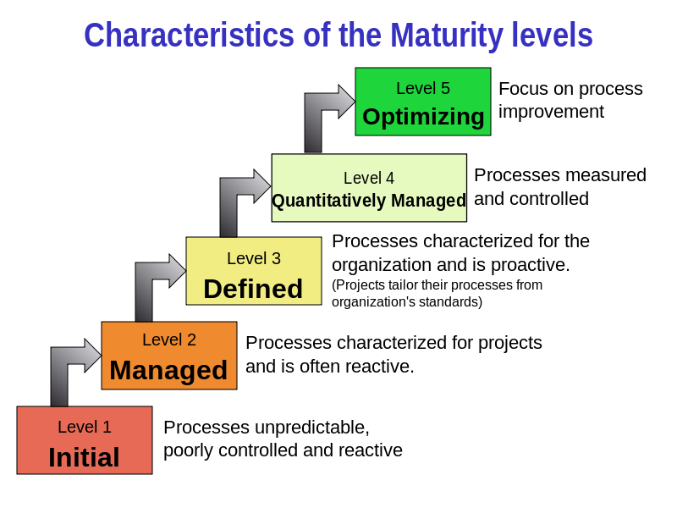
Characteristics of the Maturity levels(成熟度水平的特征)
Level 1 initial (Processes unpredictable, poorly controlled and reactive)
初始（过程不可预测，控制不良和反应性）

Level 2 managed (Processes characterized for projects and is often reactive)
管理（项目特点的过程，通常是反应性的）

Level 3 Defined(Processes characterized for the organization and is proactive……)(Projects tailor their processes from organization’s standards)
定义（组织的特征的过程，是主动的...）（项目根据组织的标准定制过程）

Level 4 Quantitatively Managed(Processes measured and controlled)
定量管理（过程测量和控制）

Level 5 Optimizing (Focus on process improvement)
优化（关注流程改进）

- IOS9001
What is the difference between CMMI and ISO9001
CMMI和ISO9001之间的区别是什么

The types of the final test exercises:
- Single Choice
- Comprehensive Question
- Calculation
- Analysis

最后测试练习的类型：
单一选择
2.综合问题
3.计算
4.分析

